11:30 am

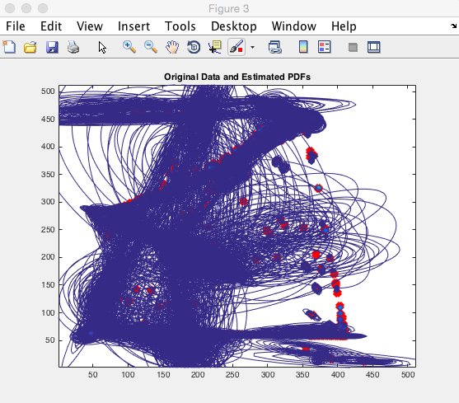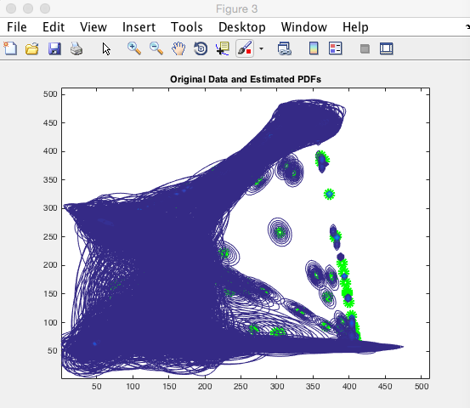

K= 1000 K= 1000

Iteration times = 1 Iteration times = 2

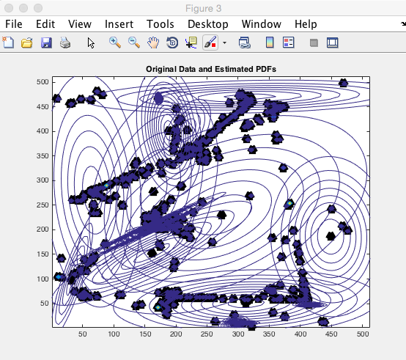

Iteration times = 3050

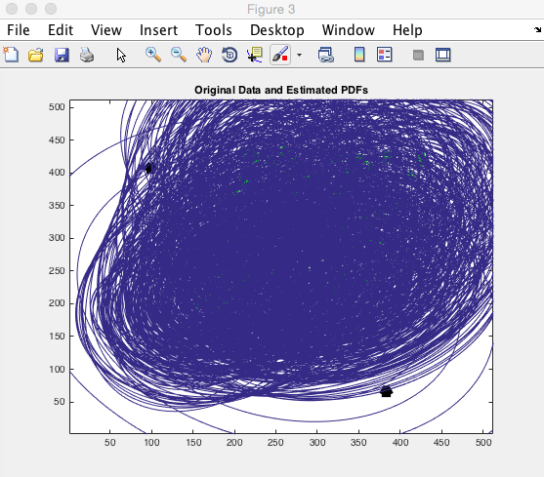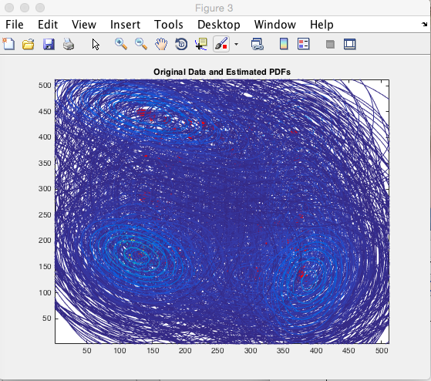

K=100

Iteration Times = 1 Iteration Times = 30

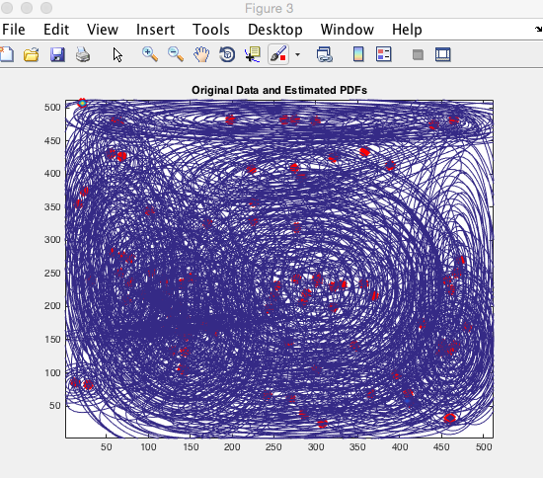

Iteration Times = 2220

Comparison between K with same small sigma

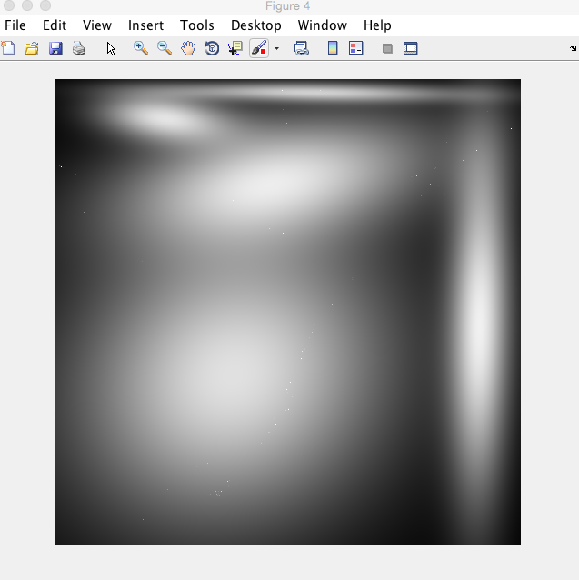

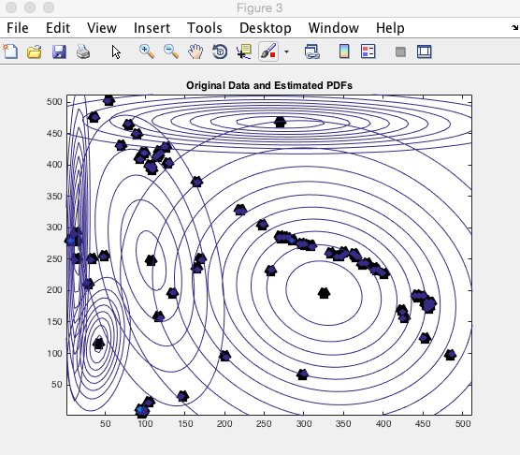

K= 100

Iteration times =10130

Sigma = [2500 0;0 2500]

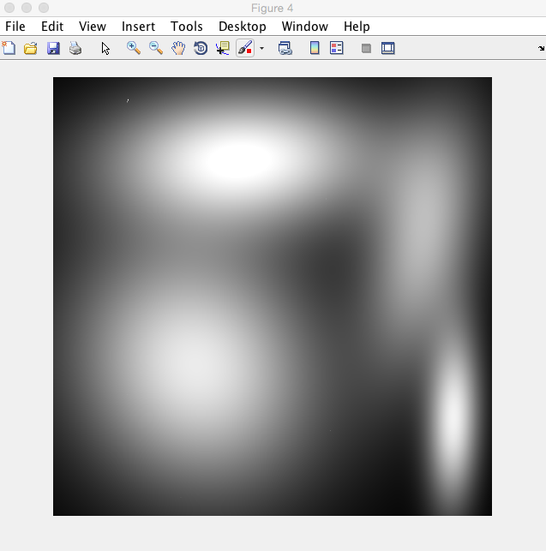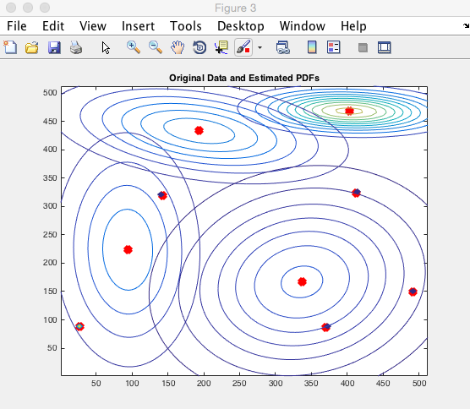

K= 10

Iteration times =15000

Sigma = [2500 0;0 2500]